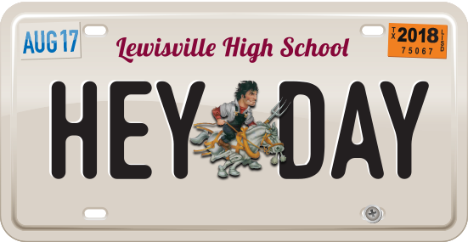

**HEY! DAY BUSINESS AND COMMUNITY FORM**

Friday, August 16, 2019

**Lewisville High School (Football Stadium) Contact: Kim Teamer**

**Event set up: 5:00-6:00 p.m. Phone: 972.998.9798**

**Event: 7-9 p.m. Email**[**: heyday@lisd.net**](mailto:heyday@lisd.net) **www**[**.lisd.net**](mailto:Heyday@lisd.net)**/heyday**

**Business Name**

**Contact Person**

**Address:**

**City/State/Zip:**

**Cell Email**

**Website**

**About Hey! Day**

*#HeyDay19 is a family-friendly, informative and fun event designed to unite the community, celebrate the new school year* *and rally support for Lewisville High School and its feeder schools. Profits are used to offset event costs and benefit education for students attending all participating campuses, including elementary schools, middle schools, LHS Harmon, LHS Killough and LHS! Your contribution is greatly appreciated. Thousands have attended Hey! Day over the past seven years.*

**Participation at Hey! Day**

**(PLEASE CHECK ALL THAT APPLY)**

**DEADLINE: FRIDAY, AUGUST 9**

**Email form to** [**heyday@lisd.net**](mailto:HeyDay@lisd.net) **or mail to:**

**Hey! Day Event, c/o Allison Stamey, 1098 W. Main Street, Lewisville TX, 75067**

**BUSINESS AND COMMUNITY BOOTH $50 (Make checks payable to LHS ABC) An invoice will be sent after receipt of your form to pay via Square. This will be done on a first come first serve basis.**

**Booth Description**

**Booth Activities**

▪  Booth space is 10x10 (can purchase additional space if necessary). Booth approval is required.

▪  **You will supply your own tables and chairs. Signage welcomed, tents prohibited.**

▪  Will you rent table and two chairs for $10? Yes No

▪  Will you provide a basket for the giveaway booth to be raffled off? Yes No

▪  See back of form for details on vendor rules and regulations. Please sign contract agreement.

**SPONSOR Make checks payable to LHS ABC.**

You can help support the wonderful Farmer tradition of Hey! Day. Each sponsor will be recognized on social media outlets and have their name announced during the event, as well as the Homecoming football game in the fall.

$500 $250 $100 $50 Other